Quotation Sheet
Ref.No.2026KPI0423-3
Date:2026/4/29
To: PT Multi Spunindo Jaya Tbk
Plot No: Desa Jabaran RT.008.003,
Kec.Balongbendo,Kab.Sidoarjo,
Jawa Timur

Description of Product | Quantity | Unit Price | Amount
Description of Product | Quantity | FOB Shenzhen Port
Double Shaft Exchanging Rewinding Machine | 1 set | USD17000.00
Total: |  |  | USD17000.00

Payment:T/T,30% in advance,70% before shipping.
Lead time:1 months after down payment
Validity time:1 month
Warranty Terms:We provide free spare parts replacement for non-artificial damage within one year.

Zhengzhou KOPY packing Equipment Co.,Ltd.

郑州科派包装设备有限公司
Zhengzhou KOPY packing Equipment Co.,Ltd.

Double shaft Rewinding Machine

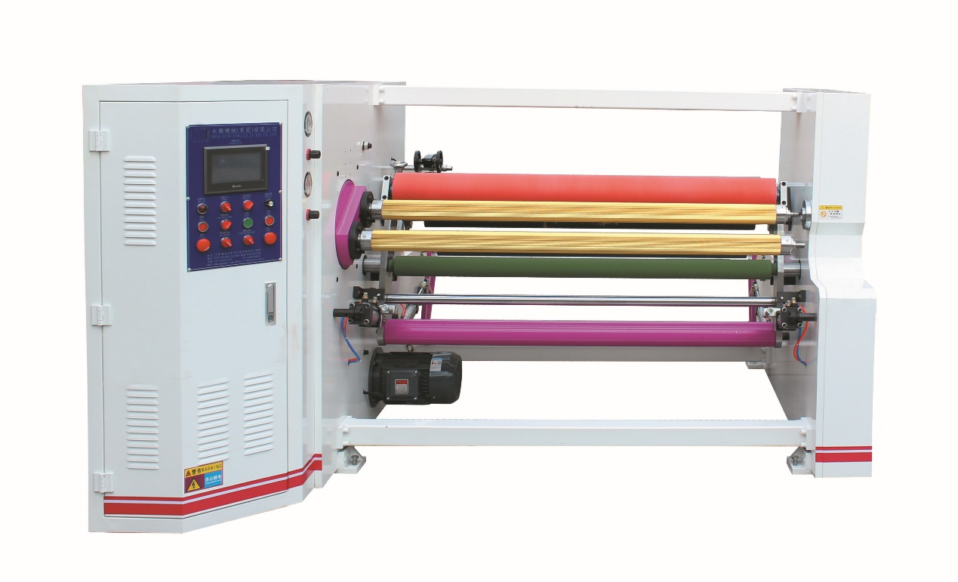
This rewinding machine is mainly used to rewind adhesive tapes like carton sealing tape, masking tape, medical adhesive tape, electric insulation tape and etc. Two winding shafts exchange automatically ensures high rewinding efficiency.

Material width (mm) | 2000
Material I.D. (mm) | 76/152 optional
Material O.D. (mm) | 1200mm Max.
Material type: | BOPP adhesive tape, masking tape
Rewind I.D. (mm) | 3 inch and 40mm
Rewind O.D. (mm) | 300mm
Speed (m/minute) | 0 - 120
Installed Power （kw） | 5.5kw, 380v/50Hz
Machine dimension (mm) | 3150 x 2380 x 1440

Components
Main motor | 4kw | 1 set | Shihlin
Main motor inverter | 4kw | 1 set | Shihlin
Rewinding clutch | 10kg magnetic clutch | 1 set | Taiwan made
Rewinding tension controller | Semi-automatic | 1 set | Taiwan made
Rewinding shaft | 76mm air expansion shaft | 3 pcs | Taiwan made
Rewinding shaft | 40mm air expansion shaft | 3 pcs | Taiwan made
cutting device |  | 1pc
Meter counter | Digital type | 1 set | Automatic stop at set length
Traction roller | Ø120 x 2150 | 1 pc | Teflon coated
Spreading roller | Ø100 x 2150 | 1 pc | Rubber coated
Rewinding pressure roller | Ø180 x 2150 | 1 pc | Rubber coated
Passing roller | Ø100 x 2150 | 3 pcs | Anodic treated
Rewinding roller support | Pneumatic cylinder | 2 sets
Rewinding roller exchange system |  | 1 set
Unwinding brake | 10kg magnetic brake | 1 set | Taiwan made
Unwinding shaft | 3” air expansion shaft | 2 pc | Taiwan made
Unwinding pressure system | Linear pressing roller mechanism | 1 set
Aligning system | Mechanic type | 2 sets
PLC | MITSUBISHI | 1 set | Japan made
HMI screen | 10” color screen | 1 set
LV parts |  |  | Schneider, Omron
Bearing |  |  | Hazhou
Pneumatic parts |  |  | SNS

